

PERSONALITY PREDICTION PROGRAM USING BAHASA INDONESIA TWEETS BASED ON “THE FIVE FACTOR MODEL” BY MCCRAE AND COSTA

Anneke Dwi Sesarika Rahmanto, Veronica Ong, Williem, Derwin Suhartono
Computer Science Department, School of Computer Science, Bina Nusantara University
Jl. K. H. Syahdan No. 9, Kemanggisan, Palmerah, Jakarta 11480, Indonesia
+62 21 534 5830 ext. 2230
anneke.rahmanto@binus.ac.id, veronica.ong@binus.ac.id, williem002@binus.ac.id, dsuhartono@binus.edu

ABSTRACT

Recent advances in technology have come up with machine learning techniques to perform automated personality assessment. This technique is possible due to the associations between personality and language. This study presents a word-based approach to build a personality prediction system based on Bahasa Indonesia tweets. The system predicts personality based on the Five Factor Model by McCrae and Costa, covering 5 traits such as Openness, Conscientiousness, Extraversion, Agreeableness, and Emotional Stability. The system is trained with 329 instances, then evaluated with 10-fold cross validation and a testing dataset of 30 instances. The prediction system is built on a Support Vector Machine and Gradient Boosting Tree algorithm. Results show that the Support Vector Machine algorithm was able to reach a highest average accuracy of 76.2310%, while the Gradient Boosting Tree 97.9962%. Evaluation results also show that n-gram features and LDA topic features contribute the most to the increase in accuracy.
Keywords: five factor model, personality prediction, Twitter

Perkembangan teknologi zaman sekarang telah memanfaatkan algoritma machine learning untuk berbagai macam hal. Salah satunya adalah penilaian kepribadian secara otomatis. Teknik ini dapat digunakan karena adanya hubungan antara kepribadian dan tata bahasa individu. Penelitian ini menggunakan pendekatan word-based untuk membangun sistem prediksi kepribadian berdasarkan tweet Bahasa Indonesia. Sistem ini memprediksi kepribadian seseorang berdasarkan model kepribadian Five Factor Model oleh McCrae dan Costa, yang meliputi 5 sifat, yaitu Openness, Conscientiousness, Extraversion, Agreeableness, dan Emotional Stability. Sistem ini dilatih dengan 329 instance, kemudian dievaluasi dengan 10-fold cross validation dan dataset testing sebanyak 30 instance. Sistem prediksi ini dibangun dengan algoritma Support Vector Machine dan Gradient Boosting Tree. Hasil evaluasi menunjukkan bahwa Support Vector Machine mampu mencapai akurasi setinggi 76.2310%, sedangkan Gradient Boosting Tree dengan akurasi 97.9962%. Hasil juga membuktikan bahwa fitur n-gram dan topik LDA mempunyai pengaruh terbesar dalam akurasi sistem.
Kata kunci: five factor model, prediksi kepribadian, Twitter

INTRODUCTION
The growth of technology has affected many aspects of human life. One of these is the increasing usage of social media. Statistics show that Twitter is the 3rd most used social media in Indonesia as of January 2016 (Kemp, 2016), and has 14.3 million users in year 2015 (eMarketer, 2015). The number of users are predicted to keep rising until 2019. The sheer amount of Twitter users also shows how much information is spread through said social media. One of these information can be the user’s personality. This is in line with a study by Kietzmann et al. (2011), which mentions that the identity block is one of the functions of social media. The identity block represents how users consciously or unconsciously reveal their identities on social media. This implies that social media contain information about the user’s personality, whether they consciously or unconsciously present their personality on their social media, including Twitter. For this reason, it would be useful to have a system that can gather and analyze user information on Twitter and create a personality prediction from it.
Researchers have shown interest in personality prediction. Figure 1 shows the number of publications on Google Scholar when searched with the query “personality (prediction OR recognition OR classification”. The figure shows a rise of publications every year.

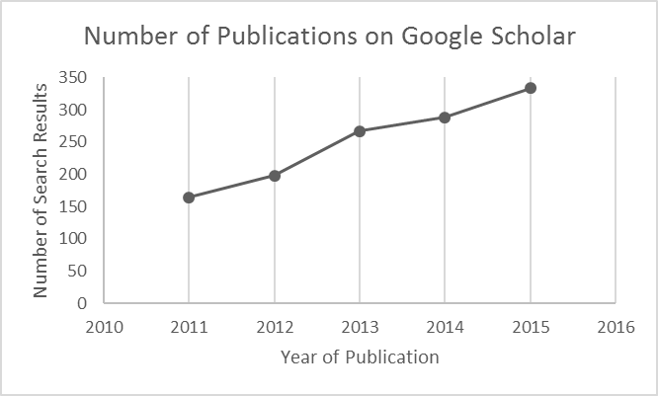
Figure 1. Number of personality prediction publications per year on Google Scholar

An attempt in using personality recognition tool on Twitter is observed from Celli (2011)’s study. A personality and language annotated corpus of 25700 posts from Twitter called “Personalitwit” was created using language identification and personality recognition tools. This corpus includes various information such as username, post, date, posting platform, personality model, accuracy of personality model, validity of personality model, and language. The personality annotation has a mean accuracy of 0.6651 and mean validity of 0.6994. The author was able to find correlations between topics, posting platform and personality. One of the mentioned correlations was that Blackberry and iPhone users produce more flat personality types since they tend to post very short messages.
Golbeck, Robles, Edmondson, & Turner (2011) built a personality prediction system based on Twitter data using machine learning techniques. A total of 50 users were recruited for the study, where 2000 tweets were collected from each user. They collected each user’s number of followers, number of following, density of social network, number of mentions (@), number of replies, number of hashtags, number of links, and words per tweet. The study utilized 2 tools, namely LIWC (Linguistic Inquiry and Word Count) and MRC Psycholinguistic Database. Both tools are used to collect features from text. The machine learning algorithms applied to the study were Gaussian Process and ZeroR. The system was able to achieve the least Mean Absolute Error using Gaussian Process at 0.11922558.
Another personality prediction system was attempted by Sumner, Byers, Boochever, & Park (2012). A total of 2,927 user behaviors and language use of Twitter users were utilized in this study. Processing the data produced 586 features, such as friends, followers, number of tweets, and the frequency of pre-defined words from LIWC. The study compared the results from 4 types of algorithms, namely Support Vector Machine, Random Forest, J48, and Naïve Bayes. The study concluded that there are relationships between Twitter activity and personality traits.
Wijaya, Prasetia, Febrianto, & Suhartono (2016) also conducted a study on personality prediction. They extracted information from 4429 Twitter users. The extraction includes Twitter username, user tweets, number of followers, number of following, number of favorited tweets, number of mentions, and number of hashtags. Features were extracted using LIWC and MRC Psycholinguistic Database. This produced a total of 27 features. The system was then built with the Support Vector Machine, ZeroR, and Naïve Bayes machine learning algorithm. The study found that Support Vector Machine gave the best result among other algorithms.
The studies mentioned above utilized a pre-defined set of words from tools (i.e. LIWC, MRC). In Yarkoni (2010)’s study, this was referred to as the category-based approach. Yarkoni also tested on a word-based approach, where word tokens are extracted from the dataset itself. The study was conducted on 694 blogs. As a result, he managed to find correlations between language and personality. Results show that word-based approach results converged with results from the category-based approach. The study also mentions that the word-based approach was also able to identify unanticipated correlations and additional correlations which were masked by the category-based approach.
Another word-based approach study was conducted by Iacobelli, Gill, Nowson, & Oberlander (2011). The study utilized data from 3000 bloggers. The study used varied datasets. The variations used are different window sizes (unigrams or bigrams), inclusion of stop words (include stop words or omit stop words), and weighting scores (Boolean or TF-IDF). The classification was done using Support Vector Machine and LibLinear. Results from the study show that the highest accuracy was achieved with Boolean weighting, bigrams, and inclusion of stop words. This scenario was also able to outperform the scenario in which LIWC was used, which implies that word-based approach too, can be used to build personality prediction systems.
Peng, Liou, Chang, & Lee (2015) performed a word-based approach on a Facebook dataset for a non-English language. The study collected data from 222 Facebook users who post in Chinese. Tokenization was done using a segmentation tool called Jieba. Extraction of language features were done with a bag-of-words model which used a TF and TF-IDF weighting scheme. Afterwards, the extracted features were selected with feature selection algorithm, namely Chi-squared test and recursive feature elimination. The classification algorithm chosen for the study was Support Vector Machine. The study found that the best result was achieved using Jieba as the text tokenizer, TF weighting scheme, chi-squared test, and SVM.
Finally, a personality prediction system was also attempted by Pratama & Sarno (2015) in Bahasa Indonesia using a word-based approach. They utilized a Facebook dataset from myPersonality. The dataset was translated into Bahasa Indonesia to obtain a dataset in said language. The dataset goes through a few processes such as tokenization, stemming, and filtering (eliminating common words). The weighting scheme used for the study is TF-IDF. Instances were also reduced to obtain 750 most frequently used words. The study compared 3 algorithms: Multinomial Naïve Bayes, K-Nearest Neighbor, and Support Vector Machine. Results show that they were able to achieve the best accuracy with Multinomial Naïve Bayes, with an average accuracy of 60%.

METHODOLOGY
Building the personality prediction system consists of 3 main tasks: preparation of dataset, building the personality prediction system through training and evaluation, and implementation of the system to a real application on Android. Figure 2 shows the general flowchart of the tasks that need to be done to build the system.


Figure 2. General activity flowchart of personality prediction application

Preparation of dataset involves 2 kinds of dataset: Twitter user information and extracted LDA topics from a corpus.
Twitter user information is obtained via the Twitter API. The user’s username, tweet count, number of followers, number of following, number of favorites, and 200 latest tweets were extracted. Afterwards, unrelated elements are removed from the extracted information. The following are elements that were removed.
- Remove retweets
- Replace mentions with token
- Replace hashtag with token
- Remove hyperlink
- Remove emoji
- Remove non-Bahasa Indonesia tweets
- Remove empty tweets
- Remove tweets with only username or hashtag token
- Remove elements from other social media
- Remove excessive tweets
- Remove users with less than 20 tweets
After removal of said elements, the dataset is annotated with labels “high” or “low” for each personality trait. Annotation of personality traits are done by psychology experts who are familiar with the Five Factor Model.
LDA topics are obtained from the Bahasa Indonesia Wikipedia dump file corpus. An LDA topic is an automatically generated group of words which the LDA algorithm believes are of the same topic. The corpus is run on a topic-modelling library called Gensim, which produces 100 topics, each topic containing 20 words.
The annotated dataset contains user behavior features and n-gram features, whereas the LDA topic data contains LDA topic features. These features are combined into a dataset that will be utilized by the system. A total of 359 instances were collected, where 329 instances are utilized as training data, and 30 instances as testing data for evaluation purposes.
Building the system consists of 2 main tasks: training and evaluation. Training is done by running the system with the dataset obtained from the previous task. The system is trained with data from various scenarios as follows.
- Minimum occurrence of n-gram (1 or 2)
- Weighting scheme (Boolean or TF/raw frequency weighting)
- Usage of LDA topic feature (use LDA topic feature or no usage of LDA topic feature)
- Omission of stop words (omit stop words or don’t omit stop words)
The listed scenarios are intersected with each other to test which scenario would result in a better prediction system. There are a total of 16 scenarios when said actions are intersected with each other.
The final step is to implement the system into an Android application. The Android application is used to extract Twitter information via the Twitter API. The prediction, on the other hand, takes place in the server. Figure 3 shows the process of the application.

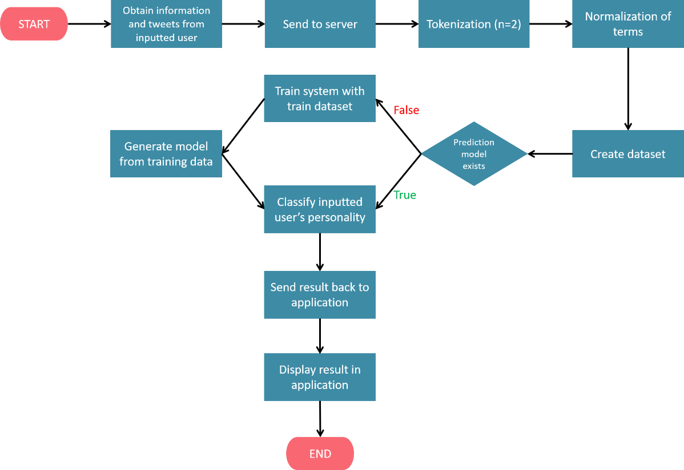
Figure 3. Process of application.

The application provides an interface where the user can input a username whose personality he/she wants to predict. The system will then obtain relevant user information via the Twitter API. Afterwards, the information is sent to the server for the prediction process. In the server, the user’s tweets will undergo n-gram tokenization of n=2. Each abnormal n-gram are normalized to their normal terms. Next, all features will be combined into a single-instance dataset for the prediction process. Before prediction, the system will detect whether a prediction model has existed. If it hasn’t, the system will first train the system with a provided training dataset. Afterwards, the system generates a prediction model so that no retraining is required during the next prediction. Finally, the single-instance dataset was run on the prediction system. Results of the prediction are returned and displayed in the Android application.

RESULT AND DISCUSSION
Evaluation of the system consists of 2 kinds of evaluation: 10-fold cross validation and evaluation on testing dataset of 30 instances. Result of each evaluation and algorithm are presented in Tables 1 to 4. The results presented are only the top 5 accuracies from each evaluation. Each row in tables 1 to 4 represent a single scenario. The cells in green represent the selected actions for each scenario. Min represents the minimum occurrence of n-gram set for that scenario. Weighting indicates the weighting scheme used in the scenario. LDA represents whether LDA topic features are used in the scenario. Stopword shows whether stopwords are omitted during that scenario. The letters A, C, ES, E and O represent each personality trait, which are Agreeableness, Conscientiousness, Emotional Stability, Extraversion, and Openness respectively. AVG stands for average, which is the average accuracy for all 5 personality traits from that scenario.
Table 1 shows the accuracy of the system using SVM evaluated with 10-fold cross evaluation. Scenario 6 with minimum occurrence 1, raw frequency weighting scheme, usage of LDA topic features, and no omission of stop words, was able to reach the highest average accuracy of 76.2310%. Scenario 5 and 13 were also able to achieve a slightly lower accuracy than scenario 6, which is 76.1702%, with minimum occurrence 2, raw frequency weighting scheme, LDA topic features, and omission of stop words. Scenario 14, which is similar to scenario 13 with no stop words omission, was able to reach an accuracy of 75.6231%. The accuracy drops to 63.1611 in scenario 8 with minimum occurrence 1, raw frequency weighting, no usage of LDA topic features, and no omission of stop words.
Table 2 presents the accuracy of the system using SVM evaluated with a testing dataset of 30 instances. The highest average accuracy is achieved in scenario 14, with minimum occurrence 2, raw frequency weighting, usage of LDA topic features, and no omission of stop words. This scenario reached an average accuracy of 80%. The second highest average accuracy was achieved by scenario 13, with minimum occurrence 2, raw frequency weighting, usage of LDA topic features, and no omission of stop words. This results in an accuracy of 79.998%. Next, the system managed to reach a lower accuracy at 67.332% with minimum occurrence 2, raw frequency weighting, usage of LDA topic features, and omission of stop words. The third highest average accuracy is achieved by scenario 16, with an average accuracy of 67.332%. Scenario 16 covers minimum occurrence 2, raw frequency weighting, usage of LDA topic features, and no omission of stop words. Scenario 6 is behind scenario 16 with an accuracy of 67.332%. The scenario covers minimum occurrence 2, raw frequency weighting, usage of LDA topic features and no omission of stop words. Scenario 7, with an accuracy slightly lower than scenario 6 has a similar scenario, with the exception of the scenario with no usage of LDA features and omission of stop words.
Table 1. Support Vector Machine Evaluation with 10-fold Cross Validation
No | min |  | Weighting |  | LDA |  | Stopword |  | A | C | ES | E | O | AVG
No | 1 | 2 | Boolean | TF | LDA | non-LDA | omit | not omit
6 |  |  |  |  |  |  |  |  | 74.4681% | 74.4681% | 75.6839% | 78.7234% | 77.8116% | 76.2310%
5 |  |  |  |  |  |  |  |  | 74.1641% | 73.8602% | 75.6839% | 79.9392% | 77.2036% | 76.1702%
13 |  |  |  |  |  |  |  |  | 75.6839% | 72.6444% | 76.8997% | 77.8116% | 77.8116% | 76.1702%
14 |  |  |  |  |  |  |  |  | 76.2918% | 68.6930% | 78.7234% | 77.2036% | 77.2036% | 75.6231%
8 |  |  |  |  |  |  |  |  | 65.9574% | 60.7903% | 55.0152% | 72.3404% | 61.7021% | 63.1611%

Table 2. Support Vector Machine Evaluation on Testing Data
No | min |  | Weighting |  | LDA |  | Stopword |  | A | C | ES | E | O | AVG
No | 1 | 2 | Boolean | TF | LDA | non-LDA | omit | not omit
14 |  |  |  |  |  |  |  |  | 76.670% | 76.670% | 83.330% | 90.000% | 73.330% | 80.000%
13 |  |  |  |  |  |  |  |  | 80.000% | 73.330% | 83.330% | 90.000% | 73.330% | 79.998%
16 |  |  |  |  |  |  |  |  | 66.670% | 60.000% | 73.330% | 83.330% | 53.330% | 67.332%
6 |  |  |  |  |  |  |  |  | 90.000% | 63.330% | 56.670% | 70.000% | 53.330% | 66.666%
7 |  |  |  |  |  |  |  |  | 66.670% | 66.670% | 60.000% | 80.000% | 56.670% | 66.002%

Table 3. Gradient Boosting Tree Evaluation with 10-fold Cross Validation
No | min |  | Weighting |  | LDA |  | Stopword |  | A | C | ES | E | O | AVG
No | 1 | 2 | Boolean | TF | LDA | non-LDA | omit | not omit
6 |  |  |  |  |  |  |  |  | 97.8700% | 98.4800% | 98.7900% | 97.5800% | 97.2600% | 97.9962%
5 |  |  |  |  |  |  |  |  | 97.5800% | 98.4800% | 98.7900% | 97.2700% | 96.9600% | 97.8163%
14 |  |  |  |  |  |  |  |  | 95.4500% | 95.7500% | 96.3600% | 94.8400% | 93.3000% | 95.1402%
13 |  |  |  |  |  |  |  |  | 95.1300% | 95.4500% | 95.4500% | 94.5400% | 93.9100% | 94.8939%
8 |  |  |  |  |  |  |  |  | 65.9600% | 61.3700% | 55.0200% | 75.9600% | 61.1000% | 63.8807%

Table 4. Gradient Boosting Tree Evaluation on Testing Data
No | min |  | Weighting |  | LDA |  | Stopword |  | A | C | ES | E | O | AVG
No | 1 | 2 | Boolean | TF | LDA | non-LDA | omit | not omit
13 |  |  |  |  |  |  |  |  | 96.6700% | 96.6700% | 100.0000% | 100.0000% | 96.6700% | 98.0020%
14 |  |  |  |  |  |  |  |  | 93.3300% | 96.6700% | 96.6700% | 96.6700% | 100.0000% | 96.6680%
11 |  |  |  |  |  |  |  |  | 60.0000% | 70.0000% | 63.3300% | 83.3300% | 56.6700% | 66.6660%
3 |  |  |  |  |  |  |  |  | 63.3300% | 70.0000% | 56.6700% | 76.6700% | 43.3300% | 62.0000%
15 |  |  |  |  |  |  |  |  | 63.3300% | 63.3300% | 56.6700% | 76.6700% | 46.6700% | 61.3340%

Table 3 shows the evaluation using the GBT algorithm with 10-fold cross validation. The highest accuracy is achieved by scenario 6 with an average accuracy of 97.9962%. Said scenario covers minimum occurrence 1, raw frequency weighting, usage of LDA topic features, and no omission of stop words. Scenario 5 managed to achieve a slightly lower scenario at 97.8163%, with minimum occurrence 1, raw frequency weighting, usage of LDA topic features, and omission of stop words. The next highest average accuracy is achieved by scenario 14 at 95.1402%, with minimum occurrence 2, raw frequency weighting, usage of LDA topic features, and no omission of stop words.
Scenario 13 resulted in an accuracy of 94.8939% with minimum occurrence 2, raw frequency weighting, usage of LDA topic features, and omission of stop words. The accuracy drops at scenario 8 to 63.8807%, with minimum occurrence 1, raw frequency weighting, no usage of LDA topic features, and no omission of stop words.
Table 4 presents the evaluation result using GBT algorithm evaluated with a testing dataset of 30 instances. Scenario 13 resulted in the highest average accuracy at 98.0020% with minimum occurrence 2, raw frequency weighting, usage of LDA topic features, and omission of stop words. Scenario 14 has the second highest average accuracy at 96.6680% with minimum occurrence 2, raw frequency weighting, usage of LDA features, and no omission of stop words. The accuracy drops drastically to 66.6660% at scenario 11, with minimum occurrence 2, Boolean weighting scheme, no usage of LDA features, and no omission of stop words. The accuracy drops again at scenario 3 to 62% with a scenario similar to scenario 11, but with minimum occurrence 1. The fifth highest average accuracy is slightly lower than scenario 3, achieving 61.3333%. This scenario consists of minimum occurrence 2, raw frequency weighting, no usage of LDA features, and omission of stop words.
Table 4 presents the evaluation result using GBT algorithm evaluated with a testing dataset of 30 instances. Scenario 13 resulted in the highest average accuracy at 98.0020% with minimum occurrence 2, raw frequency weighting, usage of LDA topic features, and omission of stop words. Scenario 14 has the second highest average accuracy at 96.6680% with minimum occurrence 2, raw frequency weighting, usage of LDA features, and no omission of stop words. The accuracy drops drastically to 66.6660% at scenario 11, with minimum occurrence 2, Boolean weighting scheme, no usage of LDA features, and no omission of stop words. The accuracy drops again at scenario 3 to 62% with a scenario similar to scenario 11, but with minimum occurrence 1. The fifth highest average accuracy is slightly lower than scenario 3, achieving 61.3333%. This scenario consists of minimum occurrence 2, raw frequency weighting, no usage of LDA features, and omission of stop words.
As seen from each evaluation, the actions that contribute to the highest average accuracy are the raw frequency weighting scheme and usage of LDA topic features.
Results also show that the GBT algorithm managed to perform better than the SVM algorithm even after applying both algorithms with the same scenarios.

CONCLUSION AND IMPROVEMENTS
This study presented a word-based approach in building a personality prediction system based on Twitter information for the Bahasa Indonesia language. The current study was able to improve the system’s accuracy from the previous study for the same language, with both the Support Vector Machine and Gradient Boosting Tree algorithm. The Support Vector Machine was able to reach a highest average accuracy of 76.2310%, while the Gradient Boosting Tree with a highest average accuracy of 97.9962%. Results also show that Gradient Boosting Tree was able to perform better than the Support Vector Machine algorithm. Finally, as seen from the evaluation results, actions which were able to contribute the most to the increase in accuracy were the raw frequency weighting scheme, and LDA topic features.

BIBLIOGRAPHY
Celli, F. (2011). Mining User Personality in Twitter, 1, 1–5.
eMarketer. (2015). Southeast Asia Has Among the Highest Social Network Usage in the World. Retrieved October 13, 2016, from http://www.emarketer.com/Article/Southeast-Asia-Has-Among-Highest-Social-Network-Usage-World/1013275
Golbeck, J., Robles, C., Edmondson, M., & Turner, K. (2011). Predicting personality from twitter. In Privacy, Security, Risk and Trust (PASSAT) and 2011 IEEE Third Inernational Conference on Social Computing (SocialCom), 2011 IEEE Third International Conference on (pp. 149–156). IEEE.
Iacobelli, F., Gill, A. J., Nowson, S., & Oberlander, J. (2011). Large Scale Personality Classification of Bloggers. In S. D’Mello, A. Graesser, B. Schuller, & J.-C. Martin (Eds.), Affective Computing and Intelligent Interaction: Fourth International Conference, ACII 2011, Memphis, TN, USA, October 9--12, 2011, Proceedings, Part II (pp. 568–577). Berlin, Heidelberg: Springer Berlin Heidelberg. http://doi.org/10.1007/978-3-642-24571-8_71
Kemp, S. (2016). 2016 Digital Yearbook. Singapore. Retrieved from http://wearesocial.com/uk/special-reports/digital-in-2016
Kietzmann, J. H., Hermkens, K., McCarthy, I. P., & Silvestre, B. S. (2011). Social media? Get serious! Understanding the functional building blocks of social media. Business Horizons, 54(3), 241–251. http://doi.org/10.1016/j.bushor.2011.01.005
Peng, K.-H., Liou, L.-H., Chang, C.-S., & Lee, D.-S. (2015). Predicting personality traits of Chinese users based on Facebook wall posts. In Wireless and Optical Communication Conference (WOCC), 2015 24th (pp. 9–14). IEEE.
Pratama, B. Y., & Sarno, R. (2015). Personality classification based on Twitter text using Naive Bayes, KNN and SVM. In 2015 International Conference on Data and Software Engineering (ICoDSE) (pp. 170–174). IEEE.
Sumner, C., Byers, A., Boochever, R., & Park, G. J. (2012). Predicting dark triad personality traits from twitter usage and a linguistic analysis of tweets. In ICMLA ’12 Proceedings of the 2012 11th International Conference on Machine Learning and Applications (Vol. 2, pp. 386–393). IEEE.
Wijaya, A., Prasetia, I., Febrianto, N., & Suhartono, D. (2016). Sistem Prediksi Kepribadian “The Big Five Traits” Dari Data Twitter. Bina Nusantara University.
Yarkoni, T. (2010). Personality in 100,000 words: A large-scale analysis of personality and word use among bloggers. Journal of Research in Personality, 44(3), 363–373.

AUTHOR BIOGRAPHY
Anneke Dwi Sesarika Rahmanto was born in the city of Denpasar on 23 August 1995. She is currently an undergraduate student in Bina Nusantara University, majoring in Computer Science since year 2013.
Veronica Ong was born in Singapore on 10 May 1995. She is currently pursuing her S1 degree in Bina Nusantara University, majoring in Computer Science since 2013.
Williem was born in Pematangsiantar on 28 February 1995. He is a Computer Science undergraduate student in Bina Nusantara University since year 2013.
Derwin Suhartono was born in the city of Pekalongan on 24 January 1988. He is currently the Head of Computer Science Program at Bina Nusantara University.

https://radimrehurek.com/gensim/

